***Method***

**Strategy of literature search**

A systematic approach was used to determine relevant articles regarding vascular calcification in patients with all stages of CKD using keywords, MeSH, or Emtree, such as ‘vascular calcification’, ‘male’ or ‘female’, and ‘renal insufficiency, chronic’ or ‘renal replacement therapy’, from databases, including PubMed, MEDLINE, EMBASE, Google Scholar, and Cochrane. Reports between 1968 and 06 May 2021 were fetched. Inclusion criteria were original reports involving human subjects that examined the relationship between gender and any types of vascular calcification, its functional candidates, or its associated predictors among the target population of CKD. Eligible studies were independently reviewed by two reviewers (P.Y.W. and C.T.C.). We excluded review articles, articles without abstract available, those that failed to measure the effects of gender on vascular calcification, its functional candidates, or its predictors in CKD patients, or non-CKD target population (Figure _). We further screened the abstracts and reference lists of the retrieved articles to identify additional studies that contained original data focusing on the same issue. Any discrepancy between the two reviewers was resolved by discussing with another senior author (___). Mostly CKD (nondialysis) was defined according to the estimated glomerular filtration rate according to the Modification of Diet in Renal Disease, but very few studies evaluated CKD based on elevated serum creatinine levels. Staging of CKD, whichever available, was performed based on the Kidney Disease Improving Global Outcome criteria (1). We extracted the following parameters from the included studies: publication data, participants’ baseline CKD stages, method of vascular calcification measurement, predictors of vascular calcification, results from univariate analyses of clinical features between male and female participants, and multivariate analyses of gender and vascular calcification associates, depending on the study design. We organized the study characteristics into the following categories: gender-related difference in prevalence of vascular calcification, gender as a risk for vascular calcification, and potential modifiers of vascular calcification determined by gender according to the relationship between gender and features of vascular calcification that were extracted. Factors adjusted for in the multivariate analyses included at least age and gender in all studies and could further include parameters such as hormones, microRNAs, proteins and laboratory profiles.

Search result: 893

Not human: 24

Not CKD: 62

Not vascular calcification: 21

Gender differences not discussed: 194

Included: 167

277+167=444

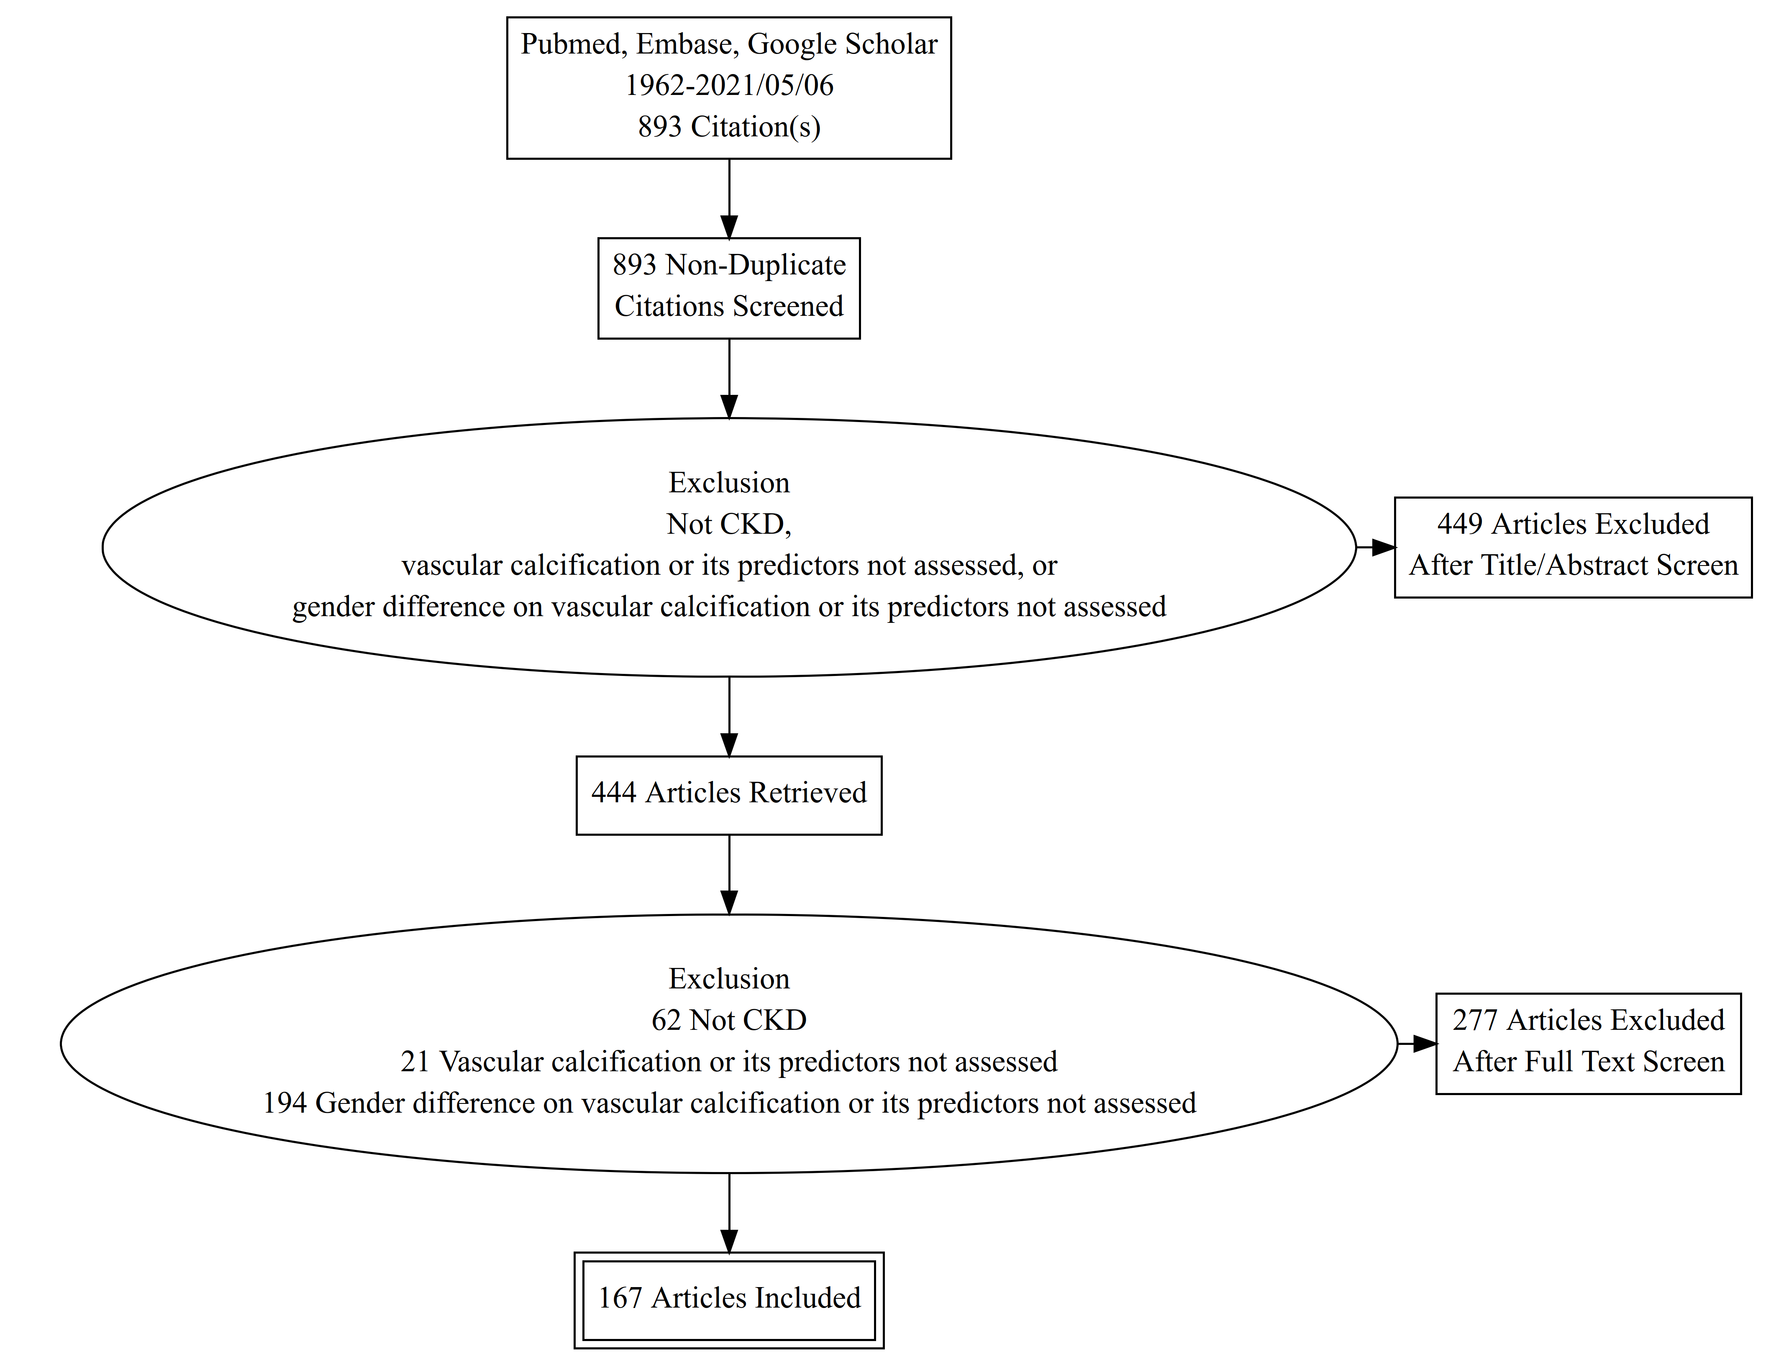

***Discussion***

**Phosphorus and vascular calcification**

Phosphorus was long believed to act a significant effect on cardiovascular calcification in chronic kidney disease-mineral bone disease by its nature of binding and depositing with calcium. However, in this review we retrieved only two studies concerning the effect of gender on phosphorus in patients with chronic kidney disease. In a study conducted by Block *et al.,* female gender served as a determinant of higher phosphorus in patients undergoing hemodialysis (2). While another study showed that gender did not modify the level of serum phosphorus (3).

**Vitamin D deficiency and vascular calcification**

Female gender had been shown to be associated with 25-hydroxyvitamin D (25D) deficiency in hemodialysis patients (4,5). However, the relationship between the serum vitamin D level and vascular calcification scores in hemodialysis patients remained unclear. Chang *et al.* illustrated a negative correlation of 25D levels with the Kauppila index in 289 hemodialysis patients from a cohort in South Korea (5). Wang *et al.* revealed a similar result, where 25D levels were negatively related to the Kauppila index in 126 hemodialysis patients from China (6). In both studies, 25D levels lost their significances after adjustment. Kanbay *et al.* studied 177 patients with CKD stages 2 to 3 (eGFR 30–90 mL/min/1.73m2), in which 25D levels showed no significant correlation with Gensini score in univariate analysis (7). The relationship between 25D and vascular calcification in different genders remained unclear, but the evidences may support some level of association between female gender and vascular calcification.

**Parathyroid hormone, sclerostin, FGF-23 and vascular calcification**

Parathyroid hormones had been shown to induce phosphaturic response, decrease reabsorption of calcium and phosphate from urine and increase uptake of calcium and phosphate from intestines and bone into the bloodstream. Patients with higher PTH showed increased risk of low bone mass, Kirkpantur *et al.* inferred a negative relation between serum PTH level and bone mineral densities, with a standard regression coefficient of -0.21– -0.33 (8). Intact PTH is shown to be related with Gensini vascular calcification score, with a correlation coefficient of 0.152, p = 0.044 (7). However, PTH levels showed no relation with vascular calcification when the calcification was assessed with SVCS in an Egypt cohort of 73 patients with CKD stages 5 to 5T (9). In a Belgium cohort with 268 kidney transplant patients, lower PTH was identified as an independent determinant of higher serum sclerostin levels, which was related to lower baseline aortic calcification score (10). Moreover sclerostin was suggested to play a role in reducing mineralization during the late phase of vascular calcification in hemodialysis patients (11). Interestingly, a very low parathyroid hormone (PTH) level (VLPL) serves as a risk of bone disease, vascular calcification, and mortality in hemodialysis patients (12). FGF-23 serves as a risk factor for an increase in Gensini score (R = 0.868; P = 0.001) in a cohort with 177 patients ranging from CKD stage 2 to 4 (7). Turan *et al.* also confirmed, although small, the risk for CACS per 50 pg/mL increase of FGF-23 in 224 hemodialysis patients (13). Tamei *et al.* conducted a study including 127 hemodialysis patients and inferred that FGF-23 serves as a significant modifier for aortic artery calcification score over progression 5 year of follow-up (14). Moreover, patients with abdominal aortic calcification of Kauppila index > 5 are prone to have impaired FGF23-induced phosphaturic response, whereas the impairment of PTH-induced phosphaturia was not discovered (15). Claes *et al.* conducted a study including 193 kidney transplant patients in Belgium and showed that PTH levels were independently associated with the prolongation of the corrected duration of QT interval (16).

**Age and vascular calcification**

Older age had been shown to associate with higher vascular calcification risk in CKD patients (9,15,17–20), but a study by Jung *et al.* on 40 hemodialysis patients in South Korea showed that age only serves as a modifier for annualized change of CAC score in male patients (R = 0.500, p = 0.009), but the same trend was not discovered in female gender (21). A France study including 24 hemodialysis patients also confirmed the exclusive relation between age and calcification in male (22). Also, an increase in age was associated with higher levels of serum sclerostin (10), suggesting sclerostin may not be a major influencer in the observed tendency of vascular calcification in older patients.

**Fetuin-A and vascular calcification**

Fetuin-A had been shown to be negatively related to bone mineral density, with standard regression coefficients ranging between -0.29 and -0.41 at different sites (radial, femur neck, and femur trochanter) (8). Interestingly, the Gensini score assessing the extent of coronary artery disease significantly correlated in univariate analysis with higher fetuin-A levels (R = 0.491; P = 0.001) (7). Moreover, low fetuin-A levels were risk factors for all-cause mortality in hemodialysis patients (HR 2.3, 95% CI 1.2–4.5) (23) and ESRD patients just prior to renal replacement therapy (RR 2.58, 95% CI 1.64–4.07). Fetuin-A was a determinant for cardiovascular mortality (RR 2.63, 95% CI 1.51–4.59) (24).

**Difference between male and female genders in the relationship of Osteoprotegerin with vascular calcification**

A study conducted by Scialla *et al.* confirmed a 30% increase in the ratio of aortic pulse wave velocity (PWV) predicted by higher osteoprotegerin when unadjusted had been elucidated. However, the effect size was lower (ratio = 1.10) when adjusted for traditional/non-traditional risk factors, and cortical bone mineral content measured by peripheral quantitative computed tomography of the left tibia (25). Male gender had been widely concerned as a risk factor for higher vascular calcification scores throughout the studies included in this review. Interestingly, female gender may still play a role in vascular calcification in CKD patients. Osteoprotegerin had been shown to predict CACS ≥ 100 with a cutoff value of 757.7 pg/mL alongside with male gender (OR 4.95, 95% CI 2.36–10.37) in a French cohort with 133 patients with CKD stages 1 to 5 (26). Although female gender was associated to a 10.2% higher serum osteoprotegerin, the association was not adjusted, indicating a lower evidence (25).

**Supplementation managements for vascular calcification in chronic kidney disease**

Vitamin D3 had long been used as a remedy for osteoporosis and vascular calcification in chronic kidney disease patients (4,27–31). Vitamin K supplements and antagonist were respectively related to lower and higher vascular calcification in chronic kidney disease patients (32). Warfarin-treated male patients had more vertebral fractures (77.8 vs. 57.7%, p<0.04), but not females (42.1% vs. 48.4%, p=0.6). Also, warfarin possesses high odd ratios of 2.58 and 2.86 for aortic and iliac artery calcifications and serves as a risk factor for all-cause mortality (HR 1.97, 95% CI 1.02–3.84) (33). More importantly, vitamin K deficiency may serve as a modifiable cardiovascular risk factor in hemodialysis patients (32). Omega-3 fatty acid supplementation increases 1,25-dihydroxyvitamin D and fetuin-A levels in dialysis patients (34).

1. Inker LA, Astor BC, Fox CH, Isakova T, Lash JP, Peralta CA, *et al.* KDOQI US commentary on the 2012 KDIGO clinical practice guideline for the evaluation and management of CKD. Am J Kidney Dis [Internet]. 2014 [cited 2021 May 24];63(5):713–35. Available from: https://pubmed.ncbi.nlm.nih.gov/24647050/

2. Block GA, Hulbert-Shearon TE, Levin NW, Port FK. Association of serum phosphorus and calcium x phosphate product with mortality risk in chronic hemodialysis patients: a national study. Am J kidney Dis Off J Natl Kidney Found. 1998 Apr;31(4):607–17.

3. Zou J, Yu Y, Wu P, Lin F-J, Yao Y, Xie Y, *et al.* Serum phosphorus is related to left ventricular remodeling independent of renal function in hospitalized patients with chronic kidney disease. Int J Cardiol. 2016;221:134–40.

4. Jean G, Charra B, Chazot C. Vitamin D Deficiency and Associated Factors in Hemodialysis Patients. J Ren Nutr [Internet]. 2008;18(5):395–9. Available from: http://search.ebscohost.com/login.aspx?direct=true&db=cin20&AN=105677388&site=ehost-live&scope=site

5. Chang JH, Ro H, Kim S, Lee HH, Chung W, Jung JY. Study on the relationship between serum 25-hydroxyvitamin D levels and vascular calcification in hemodialysis patients with consideration of seasonal variation in vitamin D levels. Atherosclerosis. 2012;220(2):563–8.

6. Wang F, Wu S, Ruan Y, Wang L. Correlation of serum 25-hydroxyvitamin D level with vascular calcification in hemodialysis patients. Int J Clin Exp Med [Internet]. 2015;8(9):15745–51. Available from: http://www.embase.com/search/results?subaction=viewrecord&from=export&id=L606756441

7. M. K, M. N, Y. S, M. I, M. A, B. E, *et al.* Fibroblast growth factor 23 and fetuin A are independent predictors for the coronary artery disease extent in mild chronic kidney disease. Clin J Am Soc Nephrol [Internet]. 2010;5(10):1780–6. Available from: http://www.embase.com/search/results?subaction=viewrecord&from=export&id=L359834071

8. Kirkpantur A, Altun B, Hazirolan T, Akata D, Arici M, Kirazli S, *et al.* Association Among Serum Fetuin-A Level, Coronary Artery Calcification, and Bone Mineral Densitometry in Maintenance Hemodialysis Patients. Artif Organs. 2009;33(10):844–54.

9. Maharem DA, Gomaa SH, El Ghandor MK, Mohamed EI, Matrawy KA, Zaytoun SS, *et al.* Association of serum fetuin-A and fetuin-A gene polymorphism in relation to mineral and bone disorders in patients with chronic kidney disease. Egypt J Med Hum Genet [Internet]. 2013;14(4):337–52. Available from: http://www.embase.com/search/results?subaction=viewrecord&from=export&id=L369999530

10. Evenepoel P, Goffin E, Meijers B, Kanaan N, Bammens B, Coche E, *et al.* Sclerostin serum levels and vascular calcification progression in prevalent renal transplant recipients. J Clin Endocrinol Metab [Internet]. 2015;100(12):4669–76. Available from: http://search.ebscohost.com/login.aspx?direct=true&db=cin20&AN=113977572&site=ehost-live&scope=site

11. Viaene L, Behets GJ, Claes K, Meijers B, Blocki F, Brandenburg V, *et al.* Sclerostin: another bone-related protein related to all-cause mortality in haemodialysis? Nephrol Dial Transplant. 2013;28(12):3024–30.

12. Jean G, Lataillade D, Genet L, Legrand E, Kuentz F, Moreau-Gaudry X, *et al.* Association between Very Low PTH Levels and Poor Survival Rates in Haemodialysis Patients: Results from the French ARNOS Cohort. NEPHRON Clin Pract [Internet]. 2011;118(2):c211–6. Available from: http://www.embase.com/search/results?subaction=viewrecord&from=export&id=L51201905

13. Turan MN, Kircelli F, Yaprak M, Sisman AR, Gungor O, Bayraktaroglu S, *et al.* FGF-23 levels are associated with vascular calcification, but not with atherosclerosis, in hemodialysis patients. Int Urol Nephrol. 2016;48(4):609–17.

14. Tamei N, Ogawa T, Ishida H, Ando Y, Nitta K. Serum Fibroblast Growth Factor-23 Levels and Progression of Aortic Arch Calcification in Non-Diabetic Patients on Chronic Hemodialysis. J Atheroscler Thromb. 2011;18(3):217–23.

15. Craver L, Dusso A, Martinez-Alonso M, Sarro F, Valdivielso JMJM, Fernández E, *et al.* A low fractional excretion of Phosphate/Fgf23 ratio is associated with severe abdominal Aortic calcification in stage 3 and 4 kidney disease patients. BMC Nephrol [Internet]. 2013;14(1). Available from: http://www.embase.com/search/results?subaction=viewrecord&from=export&id=L52814371

16. Qureshi AR, Olauson H, Witasp A, Haarhaus M, Brandenburg V, Wernerson A, *et al.* Increased circulating sclerostin levels in end-stage renal disease predict biopsy-verified vascular medial calcification and coronary artery calcification. KIDNEY Int. 2015;88(6):1356–64.

17. Chiu Y-W, Adler SG, Budoff MJ, Takasu J, Ashai J, Mehrotra R, *et al.* Coronary artery calcification and mortality in diabetic patients with proteinuria. Kidney Int [Internet]. 2010;77(12):1107–14. Available from: http://search.ebscohost.com/login.aspx?direct=true&db=cin20&AN=105217265&site=ehost-live&scope=site

18. Gelev S, Spasovski G, Trajkovski Z, Damjanovski G, Amitov V, Selim G, *et al.* Factors associated with various arterial calcifications in haemodialysis patients. Prilozi [Internet]. 2008;29(2):185–99. Available from: http://search.ebscohost.com/login.aspx?direct=true&db=cmedm&AN=19259046&site=ehost-live&scope=site

19. Chen Z, Qureshi AR, Parini P, Hurt-Camejo E, Ripsweden J, Brismar TB, *et al.* Does statins promote vascular calcification in chronic kidney disease? Eur J Clin Invest [Internet]. 2017;47(2):137–48. Available from: http://www.embase.com/search/results?subaction=viewrecord&from=export&id=L614236354

20. Golembiewska E, Qureshi AR, Dai L, Lindholm B, Heimbürger O, Söderberg M, *et al.* Copeptin is independently associated with vascular calcification in chronic kidney disease stage 5. BMC Nephrol [Internet]. 2020 Feb 7;21(1):43. Available from: http://search.ebscohost.com/login.aspx?direct=true&db=cmedm&AN=32033584&site=ehost-live&scope=site

21. Jung HH, Kim S-W, Han H. Inflammation, mineral metabolism and progressive coronary artery calcification in patients on haemodialysis. Nephrol Dial Transplant. 2006;21(7):1915–20.

22. Oprisiu R, Bunea D, Tarek S, Hedi B, Fournier A. Progression of vascular calcification and dyslipidemia in patients on chronic hemodialysis [Internet]. Vol. 39, American Journal of Kidney Diseases. 2002. p. 209. Available from: https://linkinghub.elsevier.com/retrieve/pii/S0272638614700988

23. Metry G, Stenvinkel P, Qureshi AR, Carrero JJ, Yilmaz MI, Bárány P, *et al.* Low serum fetuin-A concentration predicts poor outcome only in the presence of inflammation in prevalent haemodialysis patients. Eur J Clin Invest [Internet]. 2008;38(11):804–11. Available from: http://www.embase.com/search/results?subaction=viewrecord&from=export&id=L352548873

24. Stenvinkel P, Wang K, Qureshi AR, Axelsson J, Pecoits-Filho R, Gao P, *et al.* Low fetuin-A levels are associated with cardiovascular death: Impact of variations in the gene encoding fetuin. Kidney Int [Internet]. 2005;67(6):2383–92. Available from: http://www.embase.com/search/results?subaction=viewrecord&from=export&id=L41623401

25. Scialla JJ, Leonard MB, Townsend RR, Appel L, Wolf M, Budoff MJ, *et al.* Correlates of osteoprotegerin and association with aortic pulse wave velocity in patients with chronic kidney disease. Clin J Am Soc Nephrol [Internet]. 2011;6(11):2612–9. Available from: http://www.embase.com/search/results?subaction=viewrecord&from=export&id=L362887921

26. M. M, A.-M. D, I. J, H. V, G. G, K. K, *et al.* A cut-off value of plasma osteoprotegerin level may predict the presence of coronary artery calcifications in chronic kidney disease patients. Nephrol Dial Transplant [Internet]. 2009;24(11):3389–97. Available from: http://www.embase.com/search/results?subaction=viewrecord&from=export&id=L358385284

27. Elder GJ. Calcium supplementation: lessons from the general population for chronic kidney disease and back. Curr Opin Nephrol Hypertens. 2011;20(4):369–75.

28. Brahmbhatt S, Mikhail M, Islam S, Aloia JF. Vitamin D and Abdominal Aortic Calcification in Older African American Women, the PODA Clinical Trial. Nutrients. 2020 Mar;12(3).

29. Wasilewski GB, Vervloet MG, Schurgers LJ. The Bone-Vasculature Axis: Calcium Supplementation and the Role of Vitamin K. Front Cardiovasc Med. 2019;6:6.

30. Hamano T. Mineral and bone disorders in conventional hemodialysis: Challenges and solutions. Semin Dial. 2018 Nov;31(6):592–8.

31. Hou Y-C, Lu C-L, Lu K-C. Mineral bone disorders in chronic kidney disease. Nephrology (Carlton). 2018 Oct;23 Suppl 4:88–94.

32. Caluwé R, Pyfferoen L, De Boeck K, De Vriese AS. The effects of vitamin K supplementation and vitamin K antagonists on progression of vascular calcification: ongoing randomized controlled trials. Clin Kidney J. 2016 Apr;9(2):273–9.

33. Fusaro M, Tripepi G, Noale M, Plebani M, Zaninotto M, Piccoli A, *et al.* Prevalence of Vertebral Fractures, Vascular Calcifications, and Mortality in Warfarin Treated Hemodialysis Patients. Curr Vasc Pharmacol [Internet]. 2015;13(2):248–58. Available from: http://www.embase.com/search/results?subaction=viewrecord&from=export&id=L604512509

34. An WS, Lee SM, Son YK, Kim SE, Kim KH, Han JY, *et al.* Omega-3 fatty acid supplementation increases 1,25-dihydroxyvitamin D and fetuin-A levels in dialysis patients. Nutr Res. 2012 Jul;32(7):495–502.